**Deploy MVC Web Application in Azure By Creating App Service using Visual Studio 2019**

**1. Create a MVC Application called EmployeeManagementSystem**

**(a) Folder Structure is given below:**

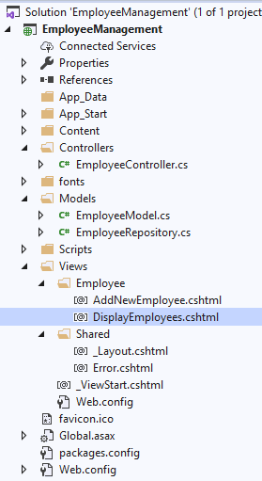

**(b) EmployeeModel.cs**

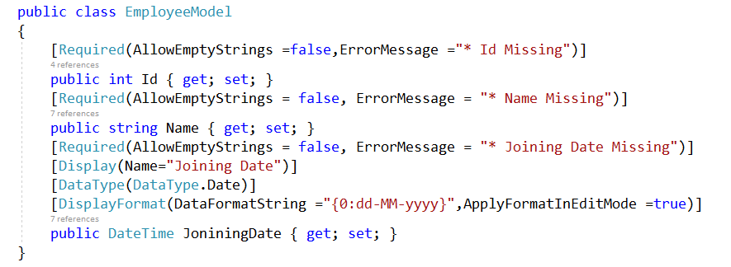

**(c) EmployeeRepository.cs**

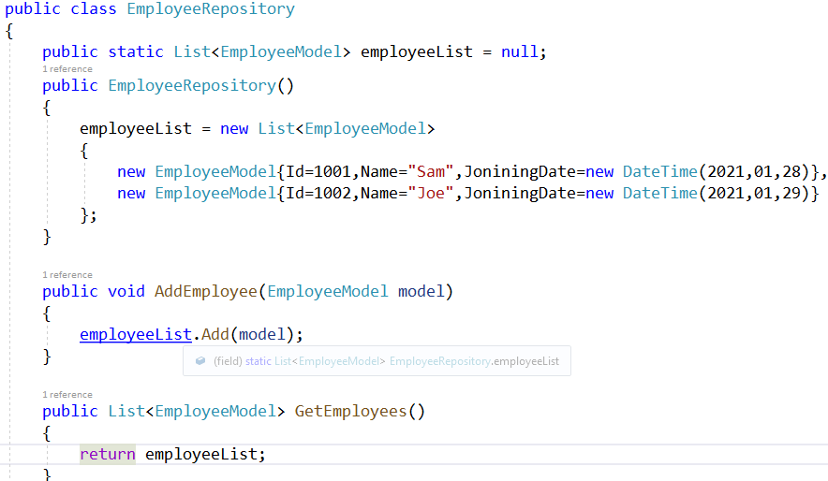

**(d) EmployeeController.cs**

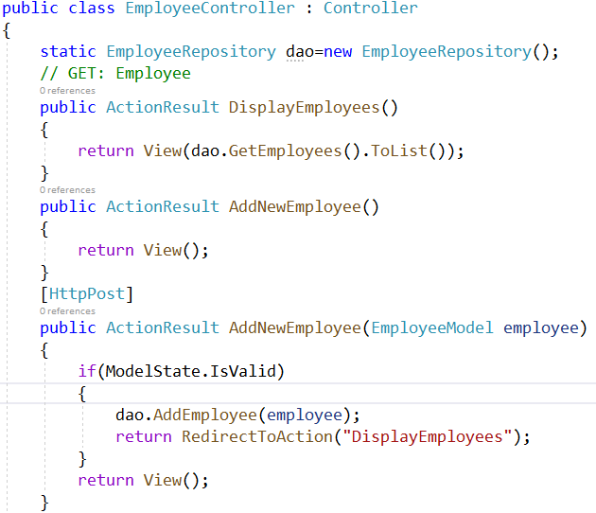

**(e) Create View Output**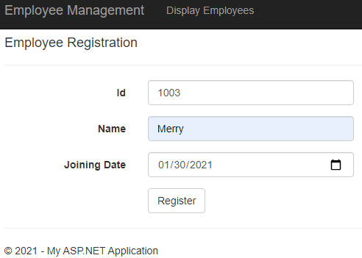

**(f) Index View Output**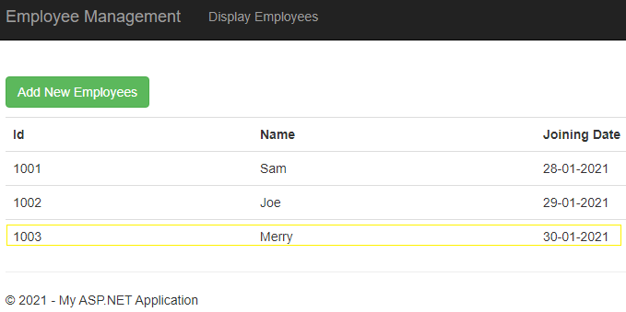

**2. To create Azure App service and publish your application do the below steps:**

**(a) Right Click over Project Name and Select Publish option**

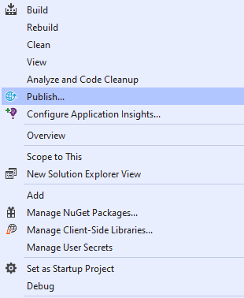

**(b) Select Azure under Publish window and click next**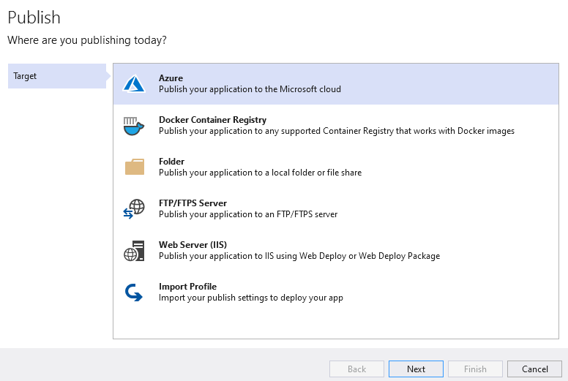

**(c) Choose Azure App Service (Wndows) option**

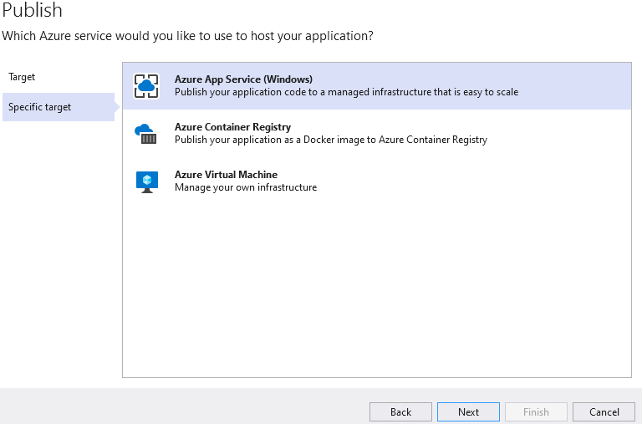

**(d) Click the + symbol to create a new App Service**

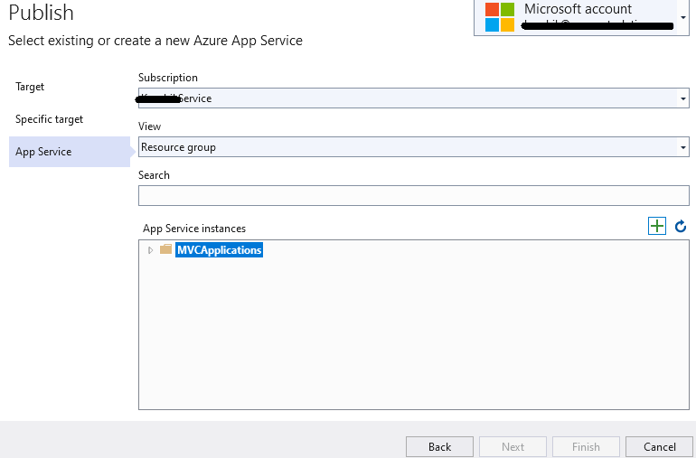

**(e) Click Create button to create the service**

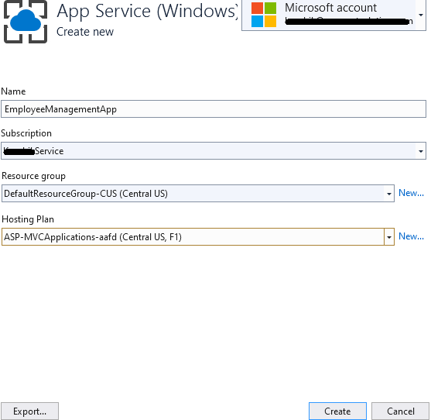

**(f) Click Finish to complete the Publish Setup**

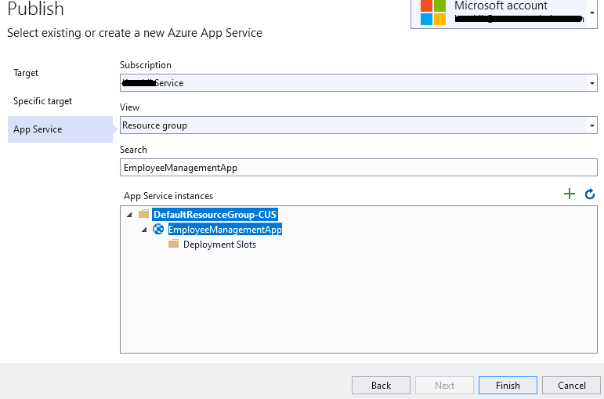

**(g) Now Click the Publish button to deploy your application on Azure**

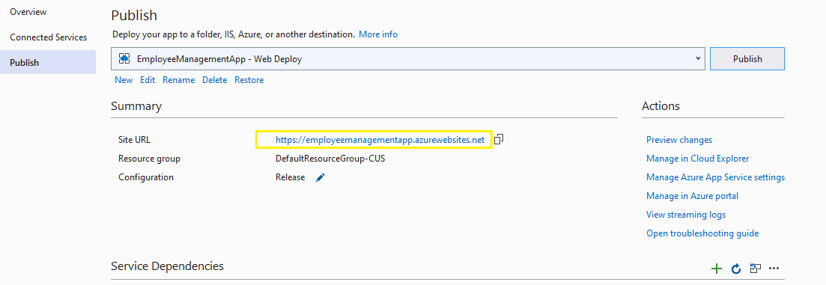

**3. Check your application by using the url (**[**https://employeemanagementapp.azurewebsites.net**](https://employeemanagementapp.azurewebsites.net)**) created while publishing your application in Azure (marked in yellow box)**

